Bottle Car

Subject: Physics, Motion and Forces  Related Subjects: Mechanical Engineering | Grade Level(s): 6–9  Length of Lesson: 110 minutes | Type: Project  Keywords: STEM, Engineering Design, Friction, Motion, Motors

Lesson Overview
In this hands-on project, students will build a simple battery-powered car using recycled bottles and basic circuitry. The activity introduces students to mechanical design, electric circuits, motion, and the engineering design process.
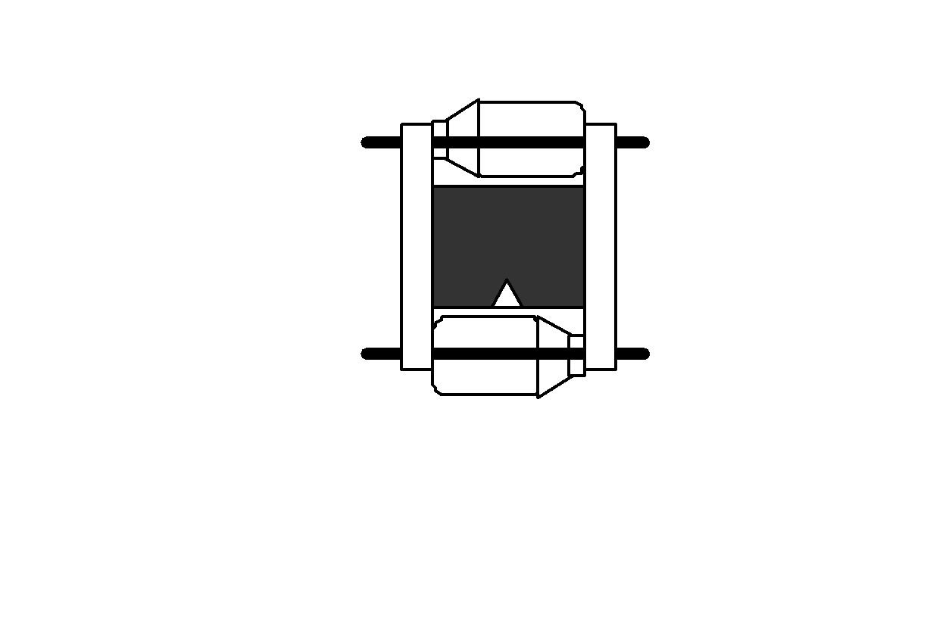

Lesson Focus
How can we use everyday materials to build a functioning car? What design elements influence the motion, direction, and speed of a bottle car?

Lesson Objective(s) | - Understand and apply the engineering design process to build a functioning bottle car.  - Explore basic concepts of force, friction, and motion.  - Build and troubleshoot a simple electrical circuit involving a motor, switch, and battery pack.  - Demonstrate knowledge of polarity, mechanical advantage, and rotational motion.  - Work collaboratively to solve design problems and optimize performance.

Lesson Timing

5 minutes | Introduce the Lesson
30 minutes | Demonstrate an example car. Safety briefing for tools. Discuss design considerations (wheel alignment, center of mass, motor connection)
60 minutes | Student building time. Testing and iteration. Teacher-led questions and troubleshooting
15 minutes | Class discussion: What worked, what didn’t? Reflection and journaling on design process

Materials | - Foam Board  - Wood sticks  - Electrical tape  - Wood Dowels  - Saw  - Wire cutters  - Wire  - Wire stripper  - Pencils  - Motors  - Battery holders  - Batteries  - Rulers  - Xacto knife  - Switches
Instructor Prep | Step 1: Prepare a completed example car for demonstration.  Step 2: Pre-cut some foam board bases and dowels for younger students if time is limited.  Step 3: Charge hot glue guns and prepare all tools at each station.  Step 4: Review electric circuit basics and be ready to troubleshoot common connection issues.  Step 5: Print step-by-step instruction sheets with diagrams for student reference.

Related Resources

Lesson Plan

Introduction
Introduce students to the goal of the lesson: to build a functioning motorized car using recycled materials and basic electronics. Begin with questions like:
- "Have you ever wondered how electric cars move?"
- "How can something as simple as a water bottle become a part of a vehicle?"
Show a short video or image of basic electric toys or electric vehicles. Discuss how engineers solve problems by building prototypes. Make connections to simple machines, circuits, and forces previously learned in class.
Step 1: Discuss the purpose of the project: building a small car using common materials to explore motion, electricity, and design. Ask students to brainstorm what they think will make the car move faster or more effectively. Prompt: What challenges might we face in making a working car?

Procedure
- Drill a hole in both ends of both water bottles (through cap)
- Cut 2 dowels about 3 inches longer than the bottles.
- Insert a dowel through both holes of water bottle (this is the wheel- axle)
- Repeat steps for the other bottle.
- Cut foam board rectangle 3” wide and 1” larger than bottle
- Cut a “V” in the center of one side of rectangle
- Cut 2 pieces of wood sticks or pvc. The wood must be long enough for both bottles to spin freely when connected to the chassis.
- Glue the foam core to the pieces of wood using the “H” shaped model.
- Strip the wires of a battery holder.
- Cut and strip a 4” wire
- Twist wire to one lead of motor and tape.
- Twist black wire from battery holder to second lead of motor and tape.
- Place red wire inside fastener and put fastener in on one end of paper clip and insert through foam board
- Place other end of 4” wire in second fastener and insert into foam board so that the other end of paper clip can overlap it when it swings around
- Place a rubber band around the spinning bottle.
- Attach wheel-axle suspension to the chassis with rubber bands (the cap of front and rear bottles should face opposite directions.
- Cut a 5mm piece of glue stick and place the holder on the end of the stem to keep the rubber band from sliding off.
- Place tape over openings on motor and glue motor to chassis with the stem parallel to wheel axis and over the “V” Stem facing right makes car move one way, stem facing left makes car move the other way. Students must test before gluing to determine which way to glue the motor.
- Glue battery holder and switch to foam core or wood.
- Place rubber band from can around stem of motor

Wrap-up
Wrap up by bringing the class together for reflection. Discuss:
- What made some cars move better than others?
- How did adjusting the motor or rubber band placement affect movement?
- What would you change if you were to redesign it?
STEM Career Tie-In:
- Discuss careers like mechanical engineers, automotive designers, and electric vehicle developers. Introduce underrepresented STEM figures in these roles.
- Cleanup Considerations:
- Collect all tools (wire cutters, glue guns, saws).
- Unplug hot glue guns.
- Safely dispose of wire clippings and scrap foam.
- Save motors, switches, and holders for future use.

Lesson Background for Teachers
This lesson combines mechanical design and basic circuitry, providing a tangible introduction to physics concepts such as:
- Friction
- Force and motion
- Rotational energy
- Simple electric circuits
It also promotes the engineering design process: Plan → Build → Test → Improve.

Suggested Real-World STEM Connections
Role Models in STEM:
- Ayanna Howard – Robotics Engineer and Educator, advocate for diversity in tech. Link
- Raye Montague – U.S. Navy Engineer who revolutionized ship design.
- Elena García Armada – Robotics engineer in Spain working on pediatric exoskeletons.
Real-World Applications:
- Electric vehicle design and prototyping (e.g., Tesla, Rivian)
- Sustainable design using recycled materials
- Problem-solving in disaster relief (e.g., building low-cost transport)

Lesson Variations and Options
- No motors available? Have students build rubber-band powered bottle cars instead.
- Advanced Option: Integrate solar panels for solar-powered cars.
- Younger Grades: Pre-drill holes, pre-strip wires, and use simplified switches.

Explanation
The bottle car works by converting electrical energy (from the battery) into mechanical energy (via the motor and rubber band drive system). The rubber band transmits this energy to the rotating bottle axle, which rolls the car forward. Proper alignment and balance are essential to minimize friction and maximize motion.

Key Concepts and Vocabulary
- Friction: A force that resists motion when two surfaces rub against each other.
- Circuit: A path through which electricity flows.
- Axle: A rod that connects wheels and helps them rotate.
- Polarity: Direction of electrical current; determines motor spin direction.
- Chassis: The frame of a vehicle.
- Engineering Design Process: A cycle of defining a problem, designing, building, testing, and improving a solution.

Safety Notes
- Always supervise use of hot glue guns and X-acto knives.

